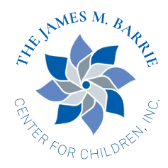
________________________________________________________________________
605 S. 4th Street Gadsden, Alabama 35901 (256) 543-1319 phone (256) 543-1519 fax

Job posting for immediate release:

Victim/Family Advocate

The James M. Barrie Center for Children, Inc., Etowah County Children’s Advocacy Center located in Gadsden, AL is currently accepting resumes for the full time position of Victim/Family Advocate. The requirements for this position includes a Bachelor’s degree in social work or related field and experience working with child victims through a Children’s Advocacy Center, DHR, law enforcement or comparable agency as well as a commitment to providing high quality services. Applicants must possess flexibility, excellent organizational/computer skills, ability to communicate well with children/adults and other professionals and a strong desire to work as a part of a team. The Victim Advocate holds a significant role in our agency as they are the first person to interact with children and families in potential times of crisis. An understanding of child development, child sexual/physical abuse and crisis services is necessary. A facility dog also works daily at the Barrie Center so comfort around a dog is required. This position is 8:00 am – 4:30 pm Monday through Friday. Please submit cover letter and resume as this position will be filled as soon as possible. Information may be sent to Patricia Falcon, Executive Director, at patricia@barriecenter.org. Please note Victim/Family Advocate in the subject line.
